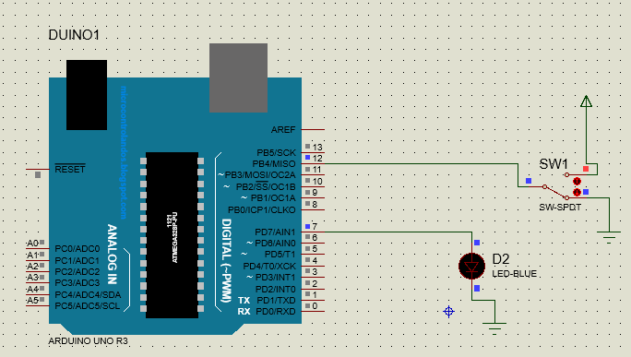

void setup() {

// put your setup code here, to run once:

pinMode(12,INPUT);

pinMode(7,OUTPUT);

}

void loop() {

// put your main code here, to run repeatedly:

int sw = digitalRead(12);

if(sw==1)

{

digitalWrite(7,HIGH);

}

else {

digitalWrite(7,LOW);

}

}